

NCIA – National Cancer Imaging Archive

Software Design Description

Release 2.0 – Verify Submission



Document Change Record
Version Number | Date | Description
1.0 | 05/26/06 | Initial document
1.1 | 07/05/06 | Updated after team review

TABLE OF CONTENTS
1. Introduction 1
1.1 PROJECT BACKGROUND 1
1.2 SYSTEM OVERVIEW 1
1.3 Requirements Traceability 2
1.3.1 Relevant Statement of Work Tasks 2
2. Use Cases 3
2.1.1 New Use Cases 3
Verify That Submitted File Were Received 3
2.1.2 Changes to Existing Use Cases 5
Manage Access to Site Data 5
3. System Architecture 7
4. configuration 8
4.1 CSM Configuration 8
4.2 NCIA.PROPERTIES 8
5. Sequence diagrams 9
5.1 Verify that submitted files were received 9
6. Components 10
6.1 USER INTERFACE 10
6.1.1 Search Page 10
6.1.2 Search Results 11
6.2 User interface Backing Beans 11
6.2.1 VerifySubmissionBean 11
6.2.2 SiteSubmissionReportDTO 12
6.2.3 SubmissionReportDateDTO 13
6.2.5 BeanManager 13
6.3 MIDDLE TIER 13
6.3.1 SitesCriteria 13
6.3.2 DateRangeCriteria 14
6.3.3 VerifySubmissionQuery 14
6.3.4 QuarantinedFileQuery 14
6.3.5 QueryType 14
6.3.6 QueryFactory 15
6.3.7 VerifySubmissionResultSet 15
6.3.8 QuarantinedFileResultSet 15
6.3.9 VerifySubmissionResultSetManager 15
6.3.10 VerifySubmissionQueryHandler 16
6.3.11 QuarantinedFileQueryHandler 16
6.4 UTILITIES 16
6.4.1 Utility class to handle quarantined files 16
6.4.2 MIRC DBExport Module 18
6.4.3 NCIAConfig Class 18
6.4.4 CSM Configuration 18
6.5 BACK END 19
6.5.1 Domain Object 19
6.5.2 Database Design 19
6.5.3 Tables 21
6.5.4 Views 21

Introduction
The purpose of this document is to describe the design for the Verify Submission feature being developed for Release 2.0 of the NCIA – National Cancer Imaging Archive software.
The enhancement will provide new functionality to allow users to search for and verify for files that have submitted to NCIA. Users will have ability to verify the number of files have been submitted successfully and number of files that placed in quarantine directory.

PROJECT BACKGROUND
Please refer to the NCIA Architecture Overview for background on the NCIA project.

SYSTEM OVERVIEW
Please refer to the NCIA Architecture Overview for a system overview.
.

Requirements Traceability

Relevant Statement of Work Tasks
The NCIA Statement of Work (SOW) Task Description contains the following items that will be implemented as part of this design:
1.3.1.1 User Submission Feedback and Review (1.1.1)
The User Submission Feedback and Review task involves the implementation of functionality that allows authorized submitters to log into the NCIA portal and navigate to the “Verify Submission” page. Specifically,
▪ The “Verify Submission” page will allow a submitter to search for files that are not yet curated. They can search by the following parameters:
o Date received
- The system will provide authorized submitters with the following information based on search criteria:
o Number of files received and accepted
o Number and list of files quarantined
- Assumptions:
o Any actions taken to resolve files quarantined or not received will be manual
o Information cannot be provided about all quarantined files

Use Cases
Verify Submission requirements were documented by a combination of adding new use cases and updating existing use cases.

New Use Cases

Verify That Submitted File Were Received
Use Case Name | Verify that Submitted Files Were Received
Use Case ID | 1.5
Primary Actor | Submitter
Trigger | Submitter wants to verify that submitted files were received.
Pre-conditions | - Submitter has submitted data (see use case 1.1 or 1.2)  - User has logged in to NCIA (see use case 8.2).  - User has been granted the VIEW_SUBMISSION_REPORT privilege in the CSM for at least one protection element representing a site.
Flow of Events | - Submitter navigates to the “Verify Submission” page.  - Submitter is presented with the following search fields:  - Site (contains a list of all sites that the user has the VIEW_SUBMISSION_REPORT privilege for in the CSM)  - Date Range  - User chooses several sites and a date range to search on and presses the Search button.  - User is presented with the following search results (grouped by site):  - Number of the following that were submitted successfully for the site on each day in the date range:  - Patients  - Studies  - Series  - Images (showing number of visible images in parentheses)  - Annotation Files  - Number of files that were quarantined that could be identified as coming from the site on each day in the date range. The system will attempt to identify the site that each file belongs to.  - For DICOM files, it will attempt to look at the header fields.  - For XML files, it will attempt to parse out the series instance UID (see use case 1.2). Based on the series instance UID, it will attempt determine the site that the file is associated with.  - For ZIP files, it will attempt to parse out the series instance UID from the manifest XML file. Based on the series instance UID, it will attempt determine the site that the file is associated with.  - Submitter is also presented with the number of files that have been quarantined but for which the site cannot be determined (for example, invalid DICOM header, no manifest in zip file, etc).
Post-Conditions | User analyzes results to determine whether all the files they submitted were received successfully. If there are any quarantined files or files that were not received, submitter calls Application Support to resolve the issue.
Alternative Flow | - User has not been granted the VIEW_SUBMISSION_REPORT privilege in the CSM for any protection elements representing a site. The link to the Submission Report page does not appear.  - User entered a date range where the From date is greater than the To date. Instead of performing the search, display the following message: “To date must be after the From date”.  - User entered a To date without a From date. Instead of performing the search, display the following message: “If a To date is included, a From date must be included.”  - User entered an invalid From Date or To Date. Instead of performing the search, display the following message: “{0} is an invalid date”, where {0} indicates the field name.  - Users entered a From date or a To date that is later than today’s date. “{0} must be not be in the future”, where {0} indicates the field name.
Related Use Cases

Changes to Existing Use Cases
The changes relevant to this enhancement are highlighted in blue.

Manage Access to Site Data

Use Case Name | Manage Access to Site Data
Use Case ID | 15.3
Primary Actor | Admin User
Trigger | Access needs to be granted or removed for a particular site’s data.
Pre-conditions | - NCIA has been registered as an application in the CSM User Provisioning Tool (UPT).  - A protection element for the site has been created.  - Admin User has been granted access to the CSM by the Super Admin User.
Flow of Events | - Admin User logs in to the CSM UPT application for NCIA.  - Admin User goes to the User Home Page  - Admin User clicks Select an Existing User to find the user that is being granted access  - Admin User grants the user the READ privilege for the protection element representing the site.  - If the user also needs permission to view the Submission Report for the site, the Admin User will grant the user the VIEW_SUBMISSION_REPORT privilege for the protection element representing the site.  - If the user also needs permission to manage curation data for the site, the Admin User will grant the user the CURATE privilege for the protection element representing the site.  - If the user also needs permission to manage the visibility status of the site, the Admin User will grant the user the MANAGE_VISBILITY_STATUS privilege for the protection element representing the site.
Post-Conditions | User is able to view data for the site.
Alternative Flow | - User needs to have access to a site removed. Admin User finds the user in UPT then removes the READ privilege for the site’s protection element.  - A decision has been made to grant all users the ability to view a site’s data. The protection element is placed in the public group, making it accessible to all users.
Related Use Case | Admin User

System Architecture
There is no change to the System Architecture for this enhancement.

configuration

CSM Configuration
Admin user will access UPT tool to create new privilege for submitter and grant VIEW_SUBMISSION_REPORT access to submitter for the protection element representing the site.

NCIA.PROPERTIES
A new date format parameter (date_format) is added to ncia.properties file.
A new property for quarantined files directory is added to ncia.properties file.
- This property needs to be made configurable using templates. In ncia.properties.template, add quarantine_directory as the value for the quarantined directory file. Then, build.xml needs to be modified to replace the value in the configuration file with the value passed in as quarantine_directory when doing a build. This allows different machines to have different quarantine directories.

Sequence diagrams
For some use cases, sequence diagrams are helpful to illustrate the execution flow. Sequence diagrams are included this section for the appropriate use cases. Details of the objects that participate in the use cases are described in section.

Verify that submitted files were received

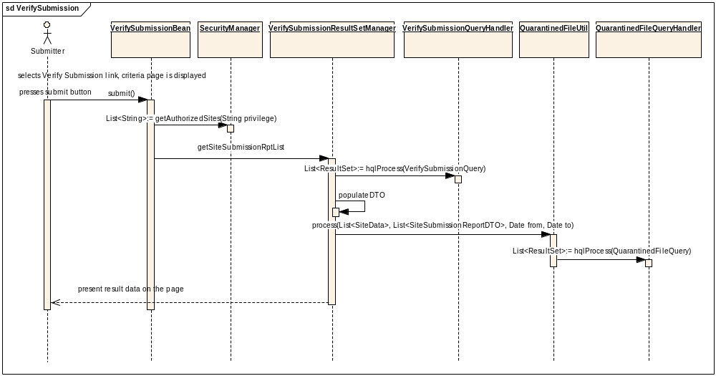

Components

USER INTERFACE
A link to the Verify Submission page will be added to the left menu. This link will only be visible to those users who have VIEW_SUBMISSION_REPORT privilege.
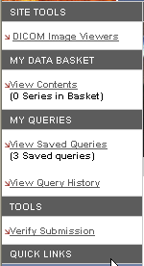

Search Page
A new Verify Submission page will be created to include the criteria to search for Project-Site and Date range. The result of the search after the submitter presses the submit button will be presented on the bottom of the same page.
The Date component of the Tomahawk.jar will be used to show popup calendar.
Filter Site List on the Search section of the page based on security. The application uses the CSM to determine which protection elements representing sites that the user has VIEW_SUBMISSION_REPORT privilege for.
The page will appear as follows:
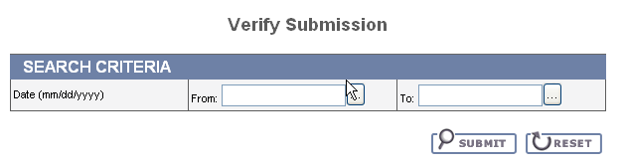

Search Results
When user presses the submit button, a textual message “Please wait. This may take a moment” is displayed to let user know that the search is in progress.
The Search Results will be presented at the bottom of the Verify Submission page after the submitter presses the submit button. The results will be grouped by Project-Site and include each date in the date range where files were submitted for Patient, Study, Series, Images and Annotation files. The number of files that were quarantined will also be presented for each Site.
A separate section of the results will present the number of the files that were quarantined but for which the site cannot be determined (for example, invalid DICOM header, no manifest in zip file, etc). It will appear as follows:

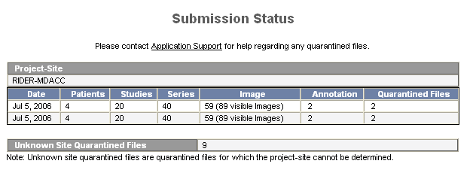

User interface Backing Beans

VerifySubmissionBean
A new backing bean (VerifySubmissionBean) will be created to manage the search process. When a user submits a query, it stores the submitted criteria and creates a VerifySubmissionQuery based on it.
New Methods | Type | Description
submit | String | Construct the criteria objects, call validateRange, add criteria for security and call query method to execute the query.
getDateFrom | Date | Get the date value from the From field
setDateFrom | void | Set the date value
getDateTo | Date | Get the date value from the To field
setDateTo | void | Set the date value
validateRange | Boolean | This method will validate the date fields. The validation rules are listed in the use case. The following error messages will be displayed:  - “To date must be after the From date.”  - “If a To date is included, a From date must be included.”  - “{0} is an invalid date”, where {0} indicates the field name.  - “{0} must not be in the future”, where {0} indicates the field name.
reset | void | Refresh the page, clear the form and remove the result section
getResults | List | Contains the results that will be displayed on the result page.

SiteSubmissionReportDTO
SiteSubmissionReportDTO will be created to hold results for a site. The following new attribute will be added:
New Attribute | Type | Description
siteName | String | hold site value
submisionRptDate | List<SubmissionReportDateDTO> | Hold list of SubmissionReportDateDTO
project | String | Hold project name

SubmissionReportDateDTO

SubmissionReportDateDTO will be created to hold data for a single day for a specific Project-Site.
New Attribute | Type | Description
submissionDate | Date | Hold submission date
numberOfImage | Integer | Hold number for images
numberOfAnnotation | Integer | Hold number of annotation files
numberOfPatients | Integer | Hold number of patients
numberOfStudies | Integer | Hold number of studies
numberOfVisibleImage | Integer | Hold number of visible images
numberOfSeries | Integer | Hold number of series
numberOfQuarantinedFile | Integer | Hold number of quarantined files

BeanManager

An existing class needs to be modified to add VerifySubmissionBean

MIDDLE TIER

SiteCriteria
A new criteria class extends TransientCriteria named SiteCriteria will be added. It will have the following attribute:
New Attribute | Type | Description
site | List<SiteData> | Set of Sites user wants to return as part of the results(SiteDate)

DateRangeCriteria
A new criteria class extends TransientCriteria named DateRangeCriteria will be added. It will have the following methods:
New Attribute | Type | Description
fromDate | Date | hold date value user selects from search page
toDate | Date | Hold date value user selects from search page

VerifySubmissionQuery
A new VerifySubmissionQuery will be created to hold the criteria.
New Attribute | Type | Description
siteCriteria | SiteCriteria | Contains site criteria for the search
dateCriteria | DateRangeCriteria | Contains date criteria for the search

QuarantinedFileQuery
A new QurantinedFileQuery class will be created to hold the criteria. This class is created because for quarantined files of type xml and zip, the project and site information will be retrieved from database.
New Attribute | Type | Description
seriesAndStudyInstanceUid | Hashmap<String, String> | Contains hashmap of seriesInstanceUid and studyInstanceUid

QueryType
This is an existing class. A new queryType named VERIFY_SUBMISSION_QUERY_TYPE will be created to handle VerifySubmissionQuery.
A new queryType named QUARANTINED_FILE_QUERY_TYPE will be created to handle QuarantinedFileQuery.

QueryFactory
This is an existing class. This class will be modified to return VerifySubmissionQuery in case the QueryType is VERIFY_SUBMISSION_QUERY_TYPE and QuarantinedFileQuery in case the QueryType is QUARANTINED_FILE_QUERY_TYPE.

VerifySubmissionResultSet
The VerifySubmissionResultSet class represents one row of data returned from the query executed by VerifySubmissionQueryHandler. It will contain the following data:
- Site Name
- Submission Date
- Number of Image
- Number of Annotation
- Number of Patients
- Number of Studies
- Number of Series
- Number of Visible Image
- Project

QuarantinedFileResultSet
The QuarantinedFileResultSet class represents one row of data returned from the query executed by QuarantinedFileQueryHandler. It will contain the following data:
- Id
- SeriesInstance UID
- StudyInstance UID
- Site Name
- Project
- Submission Date

VerifySubmissionResultSetManager
VerifySubmissionResultSetManager is responsible for the running a search based on a VerifySubmissionQuery and managing the results. This class will also handle the rolling up of the three queries (Section 6.5) to get counts for each Project-Site-Date and combines list of DTOs from queries and quarantine file utility.
The following methods will be created:
Method Name | Type | Description of Change
getSiteSubmissionReportList | List | For each VerifySubmissionResultSet returns, populate SiteSubmissionReportDTO with data. It also calls QuarantinedFilesUtil.process() method to get the number of quarantined files

VerifySubmissionQueryHandler
A new VerifySubmissionQueryHandler will be created to process VerifySubmissionQuery. To build HQL for date ranges, use the DATE_FORMAT property in ncia.properties.
New Method Name | Description
hqlProcess | Convert the VerifySubmissionQuery into hql string and run the query (ida.query()). This will be done by executing 3 queries (3 views will be created. See database section)

QuarantinedFileQueryHandler
A new QuarantindeFileQueryHandler will be created to process quarantined files.
New Method Name | Description
hqlProcess | Convert the QuarantinedFileQuery into hql string and run the query (ida.query()). This will be done by executing the query in Section 6.5.4.4

UTILITIES

Utility class to handle quarantined files
A new class QuarantinedFilesUtil.java will be created to calculate number of quarantined files for each Project-Site. This class will use the quarantined-files-directory to get all the quarantined files and loop through each one of them to determine its project-site and calculate the total count for each project-site. A file (DICOM, XML, or ZIP) will be added to unknown site quarantined files counter when the Project-Site cannot be determined.

New Method | Type | Description
Process(List<SiteData>, List<SiteSubmissiontReportDTO>, Date from, Date to) | void | Calculate the number of quarantined files

The quarantined-files-directory contains .qe files which contain the actually location of the quarantined files. The .qe file is opened and read in the actual location of the quarantined files. This location is used to open the actual file.

DICOM Files:

The following tags from the dicom header are retrieved to determine the project-site information.
00130010 106 Project Name
00130011 107 Trial Name
00130012 108 Site Name
00130013 109 Site Id

XML files:
The following series and study information are retrieved from the XML file. These values are used to lookup Project-Site information in the Database.
<SeriesInstanceUid>
<StudyInstanceUID>

Zip files:
The series and study information are retrieved from the manifest.xml file. These values are used to lookup Project-Site information in the Database.
<SeriesInstanceUid>
<StudyInstanceUID>

For XML files and Zip files, the QuarantinedFileQuery is used to hold criteria, QuarantinedFileUtil will be responsible for running the QuarantinedFileQueryHandler and managing the results.

Note: There is a bug in MIRC software that needs to be fixed for this enhancement. Currently dicom header (project name, trial name, site name, and site id) in dicom quarantined files were removed. A status check needs to perform before removing the header from dicom file.

The following sql is built to get Project and Site given series instance UID and study instance UID: Using OR for more than one set of series instance uid and study instance uid.
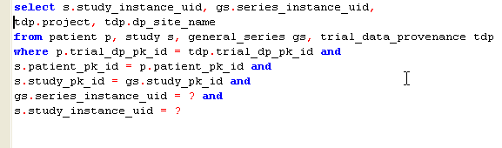

MIRC DBExport Module

When saving annotation data the database, the submissionDate for AnnotationImpl is set to the system date.

NCIAConfig Class
A new entry will be added in ncia.properties file to specify the date format. NCIAConfig class will be modified to read in this entry, add method getDateFormat(String) that converts the string into a dateFormat and return that DateFormat.
The purpose of providing a date-format in the ncia.properties file is to allow users who use other type of database (mysql, db2, etc) a flexibility to providing the format for their database.
A new entry “quarantined-files-directory” will be added to ncia.properties file. NCIAConfig class will be modified to read in the value for quarantined-files-directory.

CSM Configuration
TableProtectionElement class will be modified to add List of privileges that a user has.
New Attribute | Type | Description
privileges | List | Contains a set of privileges a user has such as READ, VIEW_SUBMISSION_REPORT, etc...

The following methods in AuthorizationManager class will be modified to pass in a privilege for certain methods
public List<String> getAuthorizedCollections(String privilege)
public void authorizeSitesAndSSGs(DICOMQuery query, String privilege)
public boolean authorizeCollections(DICOMQuery query, String privilege)
private List<String> findValuesFromAuthorizationData(String tableName, String columnName, String privilege)
Appropriate calls from search pages to these methods will be modified to pass in privilege as a String.
A new method public List<String> getAuthorizedSites(String privilege) will be created to get privileges for the user.

BACK END

Domain Classes

Annotation

A new attribute is added to Annotation object to store the date when an annotation occurs.
New Attribute | Type | Description
submissionDate | Date | Hold date value when annotation file is submitted.

SubmittedVisible

This class represents the images count for all visible images.
New Attribute | Type | Description
id | Integer | Hold Series_PK_ID
project | String | Hold project name
siteName | String | Hold the data provenance site name
submissionDate | Date | Hold submission date
trialDataProvenanceId | Integer | Hold trial data provenance pk id
patientId | Integer | Hold patient pk id
studyId | Integer | Hold study pk id
numberOfImage | Integer | Hold count of image pk id

SubmittedNonVisible

This class represents the images count for all non visible images.
New Attribute | Type | Description
id | Integer | Hold Series_PK_ID
project | String | Hold project name
siteName | String | Hold the data provenance site name
submissionDate | Date | Hold submission date
trialDataProvenanceId | Integer | Hold trial data provenance pk id
patientId | Integer | Hold patient pk id
studyId | Integer | Hold study pk id
numberOfImage | Integer | Hold count of image pk id

SubmittedAnnotation

This class represents the annotation count for all images.

New Attribute | Type | Description
id | Integer | Hold Series_PK_ID
project | String | Hold project name
siteName | String | Hold the data provenance site name
submissionDate | Date | Hold submission date
trialDataProvenanceId | Integer | Hold trial data provenance pk id
patientId | Integer | Hold patient pk id
studyId | Integer | Hold study pk id
numberOfAnnotation | Integer | Hold count of image pk id

Quarantine

This class represents the information for quarantined objects.
New Attribute | Type | Description
id | Integer | Hold general series pk id
studyInstanceUid | String | Hold Study Instance UID
siteName | String | Hold the data provenance site name
project | String | Hold project name
seriesInstanceUid | String | Hold series instance UID

Database Design

The following table and views are modified / added for this enhancement.

Tables

Annotation

New column will be added to Annotation table to store date when annotation file is submitted.
Column Name | Column Type | Class / Attribute Name
SUBMISSION_DATE | DATE | Annotaion.submissionDate

Data migration: Populate submission_date column with submission_date from general_ image for series that data has already been submitted.

DDL:

ALTER TABLE annotation
ADD submission_date date;

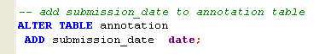

Views

SUBMITTED_VISIBLE
Column Name | Column Type | Class / Attribute Name
SERIES_PK_ID | NUMBER | SubmittedVisible.id
PROJECT | VARCHAR2 | SubmittedVisible.project
DP_SITE_NAME | VARCHAR2 | SubmittedVisible.siteName
SUBMISSION_DATE | DATE | SubmittedVisible.submissionDate
PATIENT_PK_ID | NUMBER | SubmittedVisible.patientId
STUDY_PK_ID | NUMBER | SubmittedVisible.studyId
TRIAL_DP_PK_ID | NUMBER | SubmittedVisible.trialDataProvenanceId
NUMBER_OF_IMAGES | VARCHAR | SubmittedVisible.numberOfImage

DDL:

CREATE OR REPLACE VIEW SUBMITTED_VISIBLE AS(
SELECT tdp.project, tdp.dp_site_name, trunc(gi.submission_date, 'DDD') as submission_date, tdp.trial_dp_pk_id as trial_dp_pk_id,
gi.patient_pk_id as patient_pk_id,
gi.study_pk_id as study_pk_id,
gi.general_series_pk_id as series_pk_id,
count(gi.image_pk_id) as number_of_images
FROM trial_data_provenance tdp, general_image gi
WHERE gi.trial_dp_pk_id = tdp.trial_dp_pk_id AND
gi.visibility = NULL
GROUP BY tdp.project, tdp.dp_site_name, trunc(gi.submission_date, 'DDD'),
tdp.trial_dp_pk_id, gi.patient_pk_id, gi.study_pk_id, gi.general_series_pk_id )

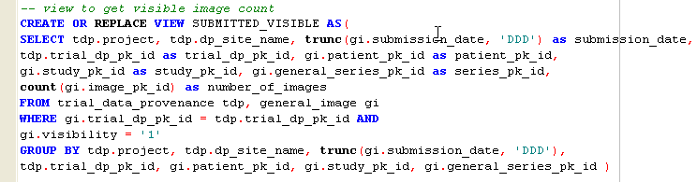

SUBMITTED_NON_VISIBLE
Column Name | Column Type | Class / Attribute Name
SERIES_PK_ID | NUMBER | SubmittedNonVisible.id
PROJECT | VARCHAR2 | SubmittedNonVisible.project
DP_SITE_NAME | VARCHAR2 | SubmittedNonVisible.siteName
SUBMISSION_DATE | DATE | SubmittedNonVisible.submissionDate
PATIENT_PK_ID | NUMBER | SubmittedNonVisible.patientId
STUDY_PK_ID | NUMBER | SubmittedNonVisible.studyId
TRIAL_DP_PK_ID | NUMBER | SubmittedNonVisible.trialDataProvenanceId
NUMBER_OF_IMAGES | VARCHAR | SubmittedNonVisible.numberOfImage

DDL:

CREATE OR REPLACE VIEW SUBMITTED_NON_VISIBLE AS(
SELECT tdp.project, tdp.dp_site_name, trunc(gi.submission_date, 'DDD') as submission_date, tdp.trial_dp_pk_id as trial_dp_pk_id,
gi.patient_pk_id as patient_pk_id,
gi.study_pk_id as study_pk_id,
gi.general_series_pk_id as series_pk_id,
count(gi.image_pk_id) as number_of_images
FROM trial_data_provenance tdp, general_image gi
WHERE gi.trial_dp_pk_id = tdp.trial_dp_pk_id AND
gi.visibility IS NULL
GROUP BY tdp.project, tdp.dp_site_name, trunc(gi.submission_date, 'DDD'),
tdp.trial_dp_pk_id, gi.patient_pk_id, gi.study_pk_id, gi.general_series_pk_id )

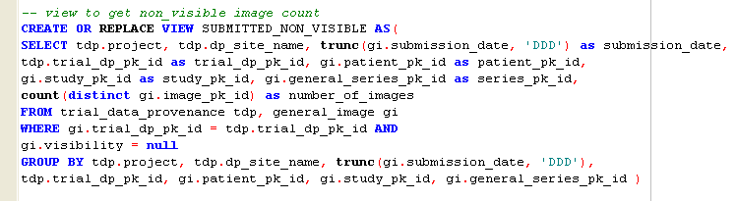

SUBMITTED_ANNOTATION
Column Name | Column Type | Class / Attribute Name
SERIES_PK_ID | NUMBER | SubmittedAnnotaion.id
PROJECT | VARCHAR2 | SubmittedAnnotaion.project
DP_SITE_NAME | VARCHAR2 | SubmittedAnnotaion.siteName
SUBMISSION_DATE | DATE | SubmittedAnnotaion.submissionDate
PATIENT_PK_ID | NUMBER | SubmittedAnnotaion.patientId
STUDY_PK_ID | NUMBER | SubmittedAnnotaion.studyId
TRIAL_DP_PK_ID | NUMBER | SubmittedAnnotaion.trialDataProvenanceId
NUMBER_OF_ANNOTATION | VARCHAR | SubmittedAnnotaion.numberOfAnnotation

DDL:

CREATE OR REPLACE VIEW SUBMITTED_ANNOTATION AS(
SELECT tdp.project, tdp.dp_site_name, trunc(a.submission_date, 'DDD') as submission_date,
tdp.trial_dp_pk_id as trial_dp_pk_id, p.patient_pk_id as patient_pk_id,
s.study_pk_id as study_pk_id, gs.general_series_pk_id as series_pk_id,
count(distinct a.annotations_pk_id) as number_of_annotation
FROM trial_data_provenance tdp, annotation a, general_series gs, study s, patient p
WHERE a.general_series_pk_id = gs.general_series_pk_id AND
tdp.trial_dp_pk_id = p.trial_dp_pk_id AND gs.study_pk_id = s.study_pk_id AND s.patient_pk_id = p.patient_pk_id
GROUP BY tdp.project, tdp.dp_site_name , trunc(a.submission_date, 'DDD'),
tdp.trial_dp_pk_id, p.patient_pk_id, s.study_pk_id, gs.general_series_pk_id )

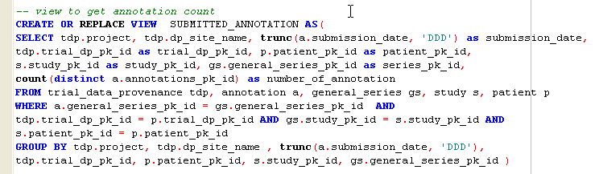

QUARANTINE
Column Name | Column Type | Class / Attribute Name
GS_SERIES_PK_ID | NUMBER | Quarantined.id
SERIES_INSTANCE_UID | VARCHAR2 | Quarantined.seriesInstanceUid
STUDY_INSTANCE_UID | VARCHAR2 | Quarantined.studyInstanceUid
DP_SITE_NAME | VARCHAR2 | Quarantined.siteName
PROJECT | VARCHAR2 | Quarantined.project

DDL:

CREATE OR REPLACE VIEW QUARANTINE AS (

SELECT gs.general_series_pk_id as gs_series_pk_id, gs.series_instance_uid, s.study_instance_uid, tdp.project, tdp.dp_site_name

FROM patient p, study s, general_series gs, trial_data_provenance tdp

WHERE p.trial_dp_pk_id = tdp.trial_dp_pk_id AND

s.patient_pk_id = p.patient_pk_id AND

s.study_pk_id = gs.study_pk_id )

